各學科之畢業論文
聖經輔導碩士科畢業論文：4個學分，包括畢業論文及一本與所學相關的工作手冊。
1. 目的：畢業論文的目的，是為要發展更多能影響教會重視以聖經和神為中心的輔導教材。
2. 主題：入學第一年須與聖經輔導碩士科系主任討論選定論文主題。應選擇自己較關心的、過去曾處理過的、及目前華人教會最欠缺或最軟弱的主題來發展論文，並與葉提多牧師課程的西敏準則（Westminster Standards）的模式結合。可以由每門輔導必修課程的作業，或與授課老師討論撰寫與論文主題相關的作業來發展論文。
3. 研究過程：
A。 圖書
一 假設您的主題是 MABC 課程涵蓋的更大主題的一部分，請查看 MABC 課程大綱中的書籍列表，作為基礎研究書籍的起點。
二. 在大型書店網站上搜尋心理學和世俗相關書籍
三. 在基督教書店網站上搜尋基督教和心理學整合書籍
四. 在保守派神學院書店 www.wtsbooks.com 上搜尋聖經輔導網站，尋找聖經輔導書籍和小冊子
五. 在中文基督教書店網站上交叉檢查是否有類似的翻譯書名 www.shop.campus.org.tw
B. 期刊文章（英文文章可以機器翻譯）
一. 對期刊文章（英文或中文）進行常規 Google 搜索
二. 在 PRTS 借閱者網站帳戶中搜尋基督教心理學或社會學期刊中的 EBSCO 相關文章
三. 在《聖經諮詢雜誌》的檔案中搜尋 BC 相關主題的文章
四. 代表組織、大學、神學院或協會的網站，若具備以下特質：由專業團隊審核編輯作者投稿內容、出版書籍或整合線上文章與期刊出版物，通常更具公信力且是撰寫論文的可靠來源。
五. 相較之下，個人作者或網紅經營的網站部落格、個人見證分享及線上文章，通常不被視為學術資源，僅應極少使用。
C。 統計研究
我。 在線查找國家新聞文章、國家或知名大學研究中心有關您主題的文章。
4. 格式：（約40,000字加上額外的練習冊/手冊）論文應包含四個部分：
a. 基本格式要求：
i. 研究論點應基於個人構思框架，整合多元來源資訊後重新編排，以體現個人思維與概念整合過程。
Page 53 學生手冊CRTS Academic Catalog 2025-28

6. 人工智慧使用規範:本院允許學生適當使用人工智慧(AI)工具、數位研究資源(如 Logos 研究工具)、線上講道網站、期刊與文章等。這些工具可用於:(1)協助學生搜尋研究資料來源(類似搜尋引擎與百科全書);(2)協助校對文字(如字典、同義詞典、拼字與文法檢查工具)。學生可於論文中使用由AI工具或其他數位來源所生成的引文、改寫或摘要內容,但必須正確註明出處(包括使用之AI工具及查詢內容)。簡而言之,學生必須是論文的真正作者,而非AI。研究與寫作的過程本身極具價值,AI可作為輔助,但不可取代。教師有權對學生於論文中過度依賴AI 而未達應有學術標準之情形給予處分。

ii. 為區分研究內容及您自己的評價總結，引用文獻時應以作者姓名開頭，並在總結或引用末尾加上註腳。其他未以作者姓名開頭的句子均視為您自己的觀點。
iii. 每節內容須持續銜接論文主題，闡明其關聯性。新章節開頭應與前章連結，並說明該章對論文主題的重要性。
iv. 論文並非書籍摘要的彙編。若單一來源連續摘要超過兩頁，將要求重寫。
引用作者觀點後，須加入個人反思、評論或批判（謹記三R原則：佐證、修正或刪除）。
v. 引言部分允許個人見證，但研究論文應淡化主觀色彩。應將個人經驗泛化為第三人稱複數表述，例如「我認識的某些女性」、「許多女性」、「包括我在內的...」、「已婚伴侶...」。
vi. 未加註解或說明而大量複製聖經經文不可接受。引用聖經經文時須說明其用意。
vii. 每頁應引用兩至五種不同來源。
viii. 作者觀點的每一句話都應有獨立腳註，除非該段落超過四行文字。
ix. 單一作者摘要超過四行時，應轉為內縮段落並於文末附註腳。整段來源摘要必須內縮並註明出處。
b. 引言：概述近期網路新聞中相關議題的初步探討，以及你基於這些新聞撰寫本論文的動機。向讀者說明後續章節架構規劃，以及本論文對現有文獻的補充價值。你計劃為該主題的知識與實踐帶來何種貢獻？
c. 第一章：
i. 選項A：使用學生設計的問卷調查，發放給教會成員的牧師或事工領袖，或針對該主題訪談成員領袖，
ii. 選項B：調研世俗心理學期刊文章與書籍，以及試圖整合心理學的基督教書籍與文章（須與論文主題相關）。需查閱至少五篇心理學期刊學術論文及十至十五本書籍，內容不需全與主題直接相關，但須涵蓋論文中提及的廣泛主題，如情緒、健康、溝通、友誼、挑戰負面思維等。需探討一至兩種主流心理學派的諮商實踐（認知行為療法或家庭系統療法通常最適用於多數論文）。
d. 第二章：綜覽聖經諮商領域已出版的專書與期刊文獻。至少參考五篇聖經輔導期刊論文，以及十至十五本保守改革宗或福音派的實踐神學或輔導書籍。這些文獻不盡然直接涉及你的主題，但其中部分探討的廣泛主題將在論文中提及。
e. 第三章：闡明《威斯敏斯特大要理問答》與你研究主題的關聯性。運用要理問答的經文索引與佐證經文，深化其主題內涵。展示葉提多牧師著作《神的榮耀》中提出的六種交響視角（第三至八章）至少一項與你主題發展的關聯性
f. 第四章：選擇與主題相關的特定經文或書卷，闡明該經文或書卷如何為處理該主題者提供輔導助益。需融入聖經神學脈絡，連結整卷書的神學主題，並運用註釋書闡釋個別經文。
g. 第五章：構建兩至三個與主題相關的假設案例，將第三至四章發展出的原則應用於輔導流程。評估並發展論文在教會輔導、培訓課程或研討會中的實務應用。
h. 附錄：編撰工作手冊／指南，以吸引人的圖文格式摘要各章內容（每章約4頁），作為小組或主日學課程的發放材料，未來可用於培訓輔導員或教會領袖。
i. 論文格式須符合本校「神學報告與論文寫作」課程所授之學術寫作規範與出版原則。所有引用來源皆須正確標註。嚴重且蓄意之剽竊行為將導致論文不合格，並提交教務委員會審議，可能面臨神學碩士課程除名處分。
5. 論文撰寫、口頭報告與畢業時程表：
a. 學生應於預定畢業年度前與指導教授討論。填妥論文註冊表，內容包含擬定論文題目、章節大綱及至少20項研究文獻（書籍、期刊文章）。經指導教授核准論文註冊表後，學生方可於學期中註冊論文。此後每月須與指導教授討論論文主題。每次會議前一日須以電子郵件提交至少10,000字內容，或預留一週時間供指導教授回覆。指導教授將確保論文達成研究目的，並協助解決撰寫過程中遇到的問題。
b. 論文口試日期定於五月上旬。除指導教授外，學生通常需提前一個月邀請兩位教師擔任評審，並於口試前兩週提交完整論文。這兩位教師將出席口試，在學生45分鐘的報告後提出問題或改進建議。指導教授將以電子郵件彙整這些建議，學生須在最終提交至圖書館前完成修改。完成口試方可參加畢業典禮。
c. 畢業前後皆可提交修訂版論文（但須完成所有要求方能領取紙本畢業證書）。印刷裝訂前，學生需準備封面頁供答辯委員會成員簽署。論文須提交一份至學校圖書館館藏（另附電子檔），並分送參與口試之教師。葉牧師僅需最終版論文的數位PDF或docx檔案。

常見的註腳錯誤 Common footnoting mistakes

從同一來源摘錄的整段內容，或超過四行的摘要或引文，都應該完全縮排。Whole sections taken from one source, or a summary or quotation more than four lines long should be completely indented.
第一張圖是錯誤的。First picture is wrong,
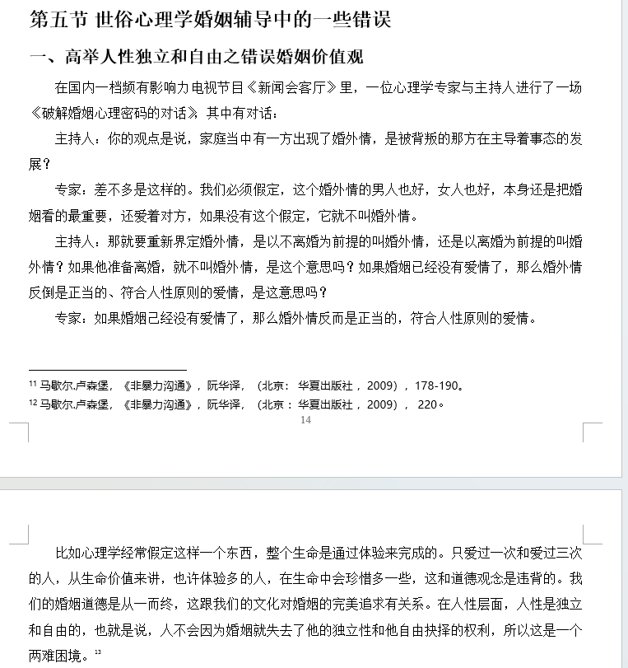

第二張圖片已修正。second picture is corrected
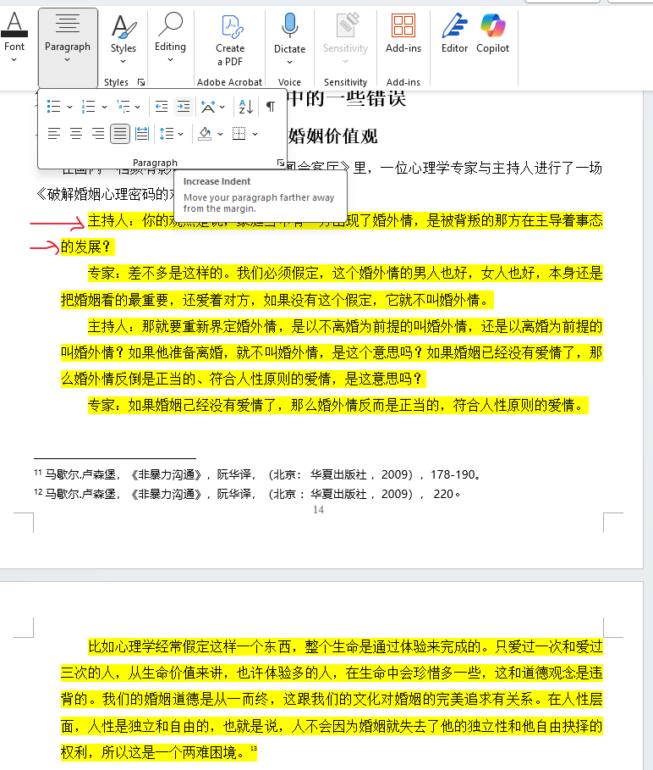

請修正所有腳註格式，尤其是在連續兩次使用相同來源的地方。檢查所有腳註是否有類似錯誤。
Correct ALL your footnote formatting in many places where you use the same source twice in a row. Check all the footnotes for similar errors

任何與#11直接同上的來源#12重複出現，請使用「同上，+頁碼」。Any repeated source #12 from directly above #11, use 同上， +page numbers。
^{[11]} 马歇尔.卢森堡，《非暴力沟通》，阮华译，（北京： 华夏出版社 ，2009），178-190。
^{[12]} 马歇尔.卢森堡，《非暴力沟通》，阮华译，（北京 ：华夏出版社 ，2009）， 220。

應該符合這種格式。should be corrected to this format
^{[11]} 马歇尔.卢森堡，《非暴力沟通》，阮华译，（北京： 华夏出版社 ，2009），178-190。
^{[12]} 同上， 220。

任何重複引用的來源，中間穿插其他來源，只需改寫作者姓名，加上「同上」和「頁碼」即可。Any repeated source with another source in between, only rewrite author's name, 同上，+page numbers.
^{[30]} 鲍会园，《罗马书（卷上）》，天道圣经注释，（香港 ：天道书楼， 2004），175。
^{[31]}王瑞珍、张圣佳编译，《新译西敏信条》，（台北 ：华神出版社， 2002），43-44。
^{[32]} 鲍会园，《罗马书（卷上）》，天道圣经注释，（香港： 天道书楼， 2004），134-135。

應該符合這種格式。should be corrected to this format
^{[30]} 鲍会园，《罗马书（卷上）》，天道圣经注释，（香港 ：天道书楼， 2004），175。
^{[31]}王瑞珍、张圣佳编译，《新译西敏信条》，（台北 ：华神出版社， 2002），43-44。
^{[32]} 鲍会园， 同上， 134-135。

改革宗神學院 論文計畫表
學生姓名 | 科系:圣经辅导
論文題目
指導教授 | 叶提多
論文架構 | 导论：  一章  1  2  二章  1  2  三章  1  2  四章  1  2  五章  1  2  六 附錄 手冊
參考書目 | 《西敏大要理》
指導教授意見/  簽名 | 簽名:

Master of Biblical Counseling thesis: Required 4 credits, including thesis and workbook/manual.
1. Purpose: The purpose of the graduation thesis is to develop more teaching materials that can influence the church to understand the importance to the Bible and God as the center of counseling.
2. Subject: In the first year of enrollment, the subject of the selected thesis must be discussed with the Dean of Biblical Counseling. You should choose a topic that you are more concerned about, have dealt with in the past, and is currently lacking as a weakness in the Chinese church, and combine it with the Westminster Standards model of Pastor Yates’ courses. The thesis can be developed by tailoring the homework of each required BC course or offering substitution homework proposals to other teachers to tailor the homework to the topic of the thesis.
3. Research process:
- BOOKS
  - Assuming your topic is part of larger topics covered in the MABC classes, review the book lists in the MABC course syllabi as a starting point for basic research book.
  - Do a search on a big bookstore website for psychology and secular related books
  - Do a search on a Christian bookstore website for Christian and psychology integration books
  - Do a search on a conservative seminary bookstore www.wtsbooks.com that teaches biblical counseling website for biblical counseling books and booklets
  - Cross-check on a Chinese Christian bookstore website for any similar translated titles www.shop.campus.org.tw
- JOURNAL ARTICLES (English articles can be machine translated)
  - Do a general Google search for journal articles (English or Chinese)
  - Search in PRTS loaner website account for EBSCO related articles in Christian psychology or sociology journals
  - Do a search in the archives of the Journal of Biblical Counseling for BC articles on related topics
  - Websites representing organizations, universities, seminaries, associations that curate and edit submission by their authors, publish books or combine online articles with journal publications are generally more recognized and reliable sources useful for your thesis.
  - Website blogs, personal testimonies and online articles from individual authors or influencers are usually not considered scholarly resources and should be used only minimally.
- STATISTICAL RESEARCH
  - Look online for national news articles, national or big-name university research centers for articles on your topic.
4. Format: (about 40,000 characters plus the additional workbook/manual) The paper should contain four parts:
- General format requirements:
  - Research thesis should be shaped by your own outline of ideas assembled from many different sources then rearranged in your own order to reflect your own thinking and assembly of the ideas.
Page 53 學生手冊CRTS Academic Catalog 2025-28
6. Guidelines for the Use of Artificial Intelligence: This college allows students to use artificial intelligence (AI) tools, digital research resources (such as the Logos research tool), online lecture websites, journals, and articles appropriately. These tools can be used to: (1) assist students in searching for research sources (similar to search engines and encyclopedias); (2) assist in proofreading (such as dictionaries, thesaurus, spelling and grammar checkers). Students may use citations, rewritten or abstracted content generated by AI tools or other digital sources in their papers, but must properly cite the sources (including the AI ​​tools used and the search results). In short, students must be the true authors of their papers, not the AI. The research and writing process itself is highly valuable; AI can be an aid, but not a substitute. Faculty members have the right to discipline students who overly rely on AI in their papers and fail to meet the required academic standards.
  - Keep the distinction between the research and your own evaluative summaries by starting citations with the name of the author and ending the summary or citation with a footnote. Other sentences not beginning with an author’s name are assumed to be your own ideas.
  - Constantly connect every new section to your thesis topic and show why this content is relevant to that topic. Connect the beginning of a new chapter to the previous chapter and state the importance of this new chapter to the thesis topic. Summarize at the end of every chapter and say why this chapter is important to your thesis and how it help understand and add new depth to understanding your topic.
  - The thesis is not a collection of book summaries. You will be asked to rewrite if you use more than two pages of continuous summary from one source. After citing an author, you should add in your own reflection, comments or criticisms, (remember three Rs reassure, reform or remove).
  - Personal testimony is permitted in your introduction, but this should be muted in a research thesis. You should generalize from your experience to third person plural, some women, many women I know, including myself . . . married couples . . . .
  - Copying extensive Bible verses without comment or explanation it not acceptable. Use of Bible verses should be explained.
  - Every page should have from two to five different sources cited.
  - Every sentence of an author’s ideas should have a separate footnote unless it exceeds four lines of text.
  - More than four lines of summary from one author should become an entire indented paragraph with one footnote at the end. A whole paragraph of summarized ideas from one source must be indented and footnoted.
- Introduction: some initial survey of this topic in recent online news articles, and your motivation for writing this thesis in response to those news articles. Tell the reader about your expected chapter development to follow and why this thesis is needed to add to the literature already available. What do you plan to contribute to the knowledge and practice of this topic?
- Chapter 1:
  - OPTION A: Use student developed survey distributed to pastors or ministry leaders of church members or interviews with leaders of members on your topic,
  - OPTION B: survey the secular psychology journal articles and books, and Christian books and articles that try to integrate psychology that have been published related to thesis topic You should access a least five scholarly articles from psychology journals, and ten to fifteen books, not all of them directly about your topic, but some about broader themes that will be mentioned in your thesis, like emotions, health, communication, friendship, challenging negative thinking. Include consideration about how one or two of the major psychological schools practice counseling in general (probably cognitive behavior therapy, or family systems therapy would work the best for most theses).
- CHAPTER 2: review Biblical counseling books and journal articles published on your topic. Consult at least five Biblical counseling journal articles, and ten to fifteen conservative Reformed or Evangelical practical theology or counseling books, not all of them directly about your topic, but some about broader themes that will be mentioned in your thesis.
- CHAPTER 3 Show how the Westminster Larger Catechism relates to your topic. Use the Catechism Scripture index and prooftexts to help develop the meaning of its topics. Show the relevance of at least one of the six symphonic perspectives developed in Pastor Yates book Westminster Foundations (chapter 3-8) to your topic development
- CHAPTER 4 Choose a specific Bible text or a Bible book that relates to your topic and show how this text or Bible book will contribute counseling help to those dealing with your topic. Add in biblical theology contextual connections to the theological themes in the whole Bible book and while individual verses should be explained using commentaries.
- CHAPTER 5: develop two or three hypothetical cases that relate to your topic and apply the principles developed in chapters 3-4 to your counseling process. Evaluate and develop the practical application of the thesis in the church for counseling, training courses or seminars.
- APPENDIX: Develop a workbook /manual that summarizes each chapter in about 4 pages each chapter using an attractive graphics format that could be used as handouts in a small group or Sunday School class as a tool to train counselors or church leaders in the future.
- The format of the thesis should conform to the essay writing format and publishing principles taught in " Writing Theological Reports and Essays " of our school. All sources used must be properly cited. Serious and intentional plagiarism will result in failing the thesis and will be referred to the faculty for a possible decision about being expelled from the MABC program.
5. TIMETABLES for paper writing, oral presentation and graduation:
- Student should discuss with the advisor before the graduation year of the planned graduation year. Complete the thesis registration form that includes the proposed thesis title, the chapter outline, and at least 20 research sources (books, articles). After faculty advisor approval of your thesis registration form, the student can register for the thesis during the school semester. After that, student is expected to discuss the topic of the thesis with the advisor every month. The advisor expects at least 10,000 words emailed a day before each scheduled meeting, or give advisor a week to respond by email. Your advisor will make sure you fulfill the purpose of the thesis, and solve any problems faced in the process.
- The oral defense date of the thesis will be scheduled in early May. In addition to the faculty advisor, students normally ask two other teachers about one month in advance and give them the completed thesis two weeks before the oral presentation. Those two teachers will come to the presentation and after your 45-minute presentation will ask questions or make comments suggestion for improvements. The thesis advisor will summarize these recommendations in an email and the student will be expected to make those improvements prior to final submission to the library. Oral presentation must be completed to participate in graduation.
- Submit the revised thesis before or after graduation (but you will not receive your printed diploma until you have fulfilled all requirements). Before printing and binding, the defense committee member's signatures will be provided on a student prepared cover page. One copy of the essay should be sent to the school library collection (plus an electronic file) and any teacher who participates in the oral exam. Dr Yates only wants the final thesis as a digital PDF or docx file.

